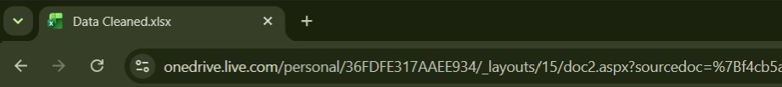
onedrive.live.com/personal/36FDFE317AAEE934/_layouts/15/doc2.aspx?sourcedoc=%7Bf4cb5a
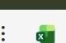 Data Cleaned p Search for tools, help, and more (Alt
File Home Insert Share Page Layout Formulas Data Review View Help Draw
9 Ger
Al name
c
1 | name | planet sta mass mass errcmass errcmass sinl mass sinl mass Sinl radius radius error min  Confirmed 5.743 0.289 1.011 6.383 0.078 0.078 1.152 0.02 Confirmed 0.37 0.005 0.004 0.033 0.005 0.004 0.219 0.02  Confirmed 9.866 1.781 3.19 0.7315 0.0493 0.05 0.219 0.02  Confirmed 0.37 1.1 1.1 11.0873 1.1 1.1 0.219 0.02  Confirmed 0.37 0.23 0.23 4.684 0.23 0.219 0.02  Confirmed 8.9 1.7 1.3 4.95 0.0493 o.219_ 0.02  Confirmed 7.9 1.2 1.6 7.12 0.0493 0.05 0.219 0.02  Confirmed 0.37 0.08 0.08 1.64 0.08 0.08 0.219 0.02 Confirmed 0.37 0.36 0.36 10.3 0.36 0.36 0.219 0.02  Confirmed 0.37 0.02 0.02 1.59 0.02 0.02 0.219 0.02  Confirmed 0.37 0.03 0.03 0.82 0.03 0.03 0.219 0.02  Confirmed 0.37 0.11 0.11 0.91 0.11 0.11 0.219 0.02  Confirmed 0.37 0.11 0.11 1.84 0.11 0.11 0.219 0.02  Confirmed 0.37 0.2 0.2 1.52 0.2 0.2 o.219_ 0.02 Confirmed 0.37 0.2 1.8 8.3 0.2 1.8 0.219 0.02  Z Onnfirrnp.S  Sheetl Sheet2 Sheet3 Sheet4 in
2  3  4  5  6  7  8  9  10  11  12  13 14  15  16 | 109 Psc b  112 Psc b  112 Psc c  11 UMi b 14 And Ab  14 Her b  14 Her c  16 cyg Bb  18 Del Ab  - Lib b 23 Lib c 24 Boo b  - Sex b  24 Sex c  2M 1253+  S In I  Workbook Statistics
p Type here to search
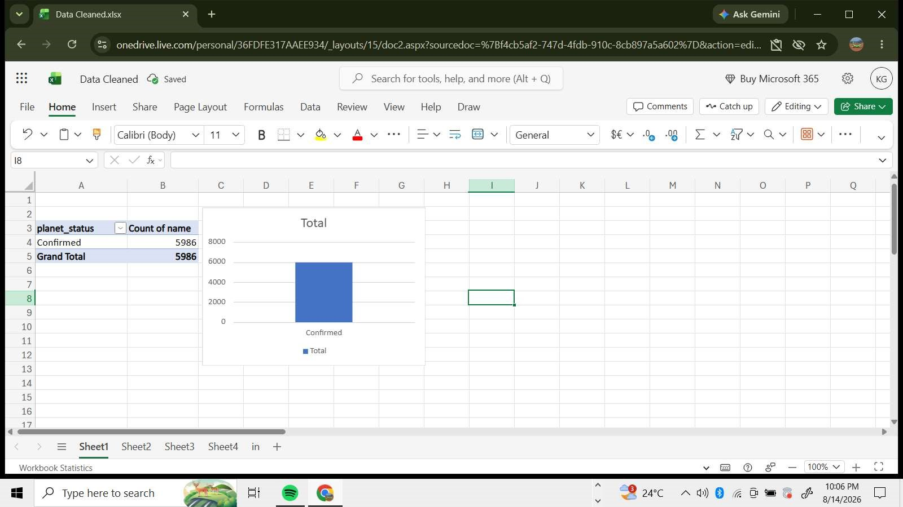
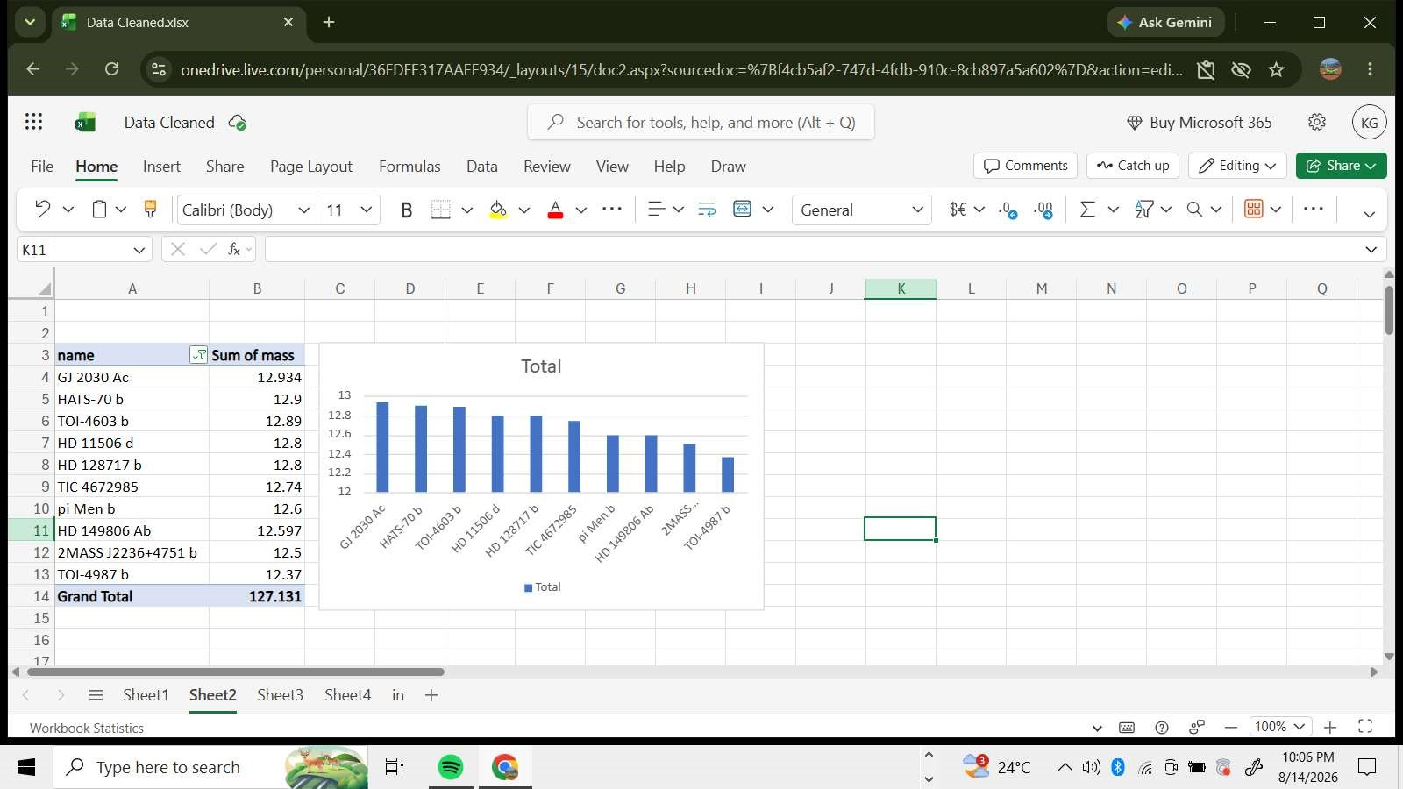

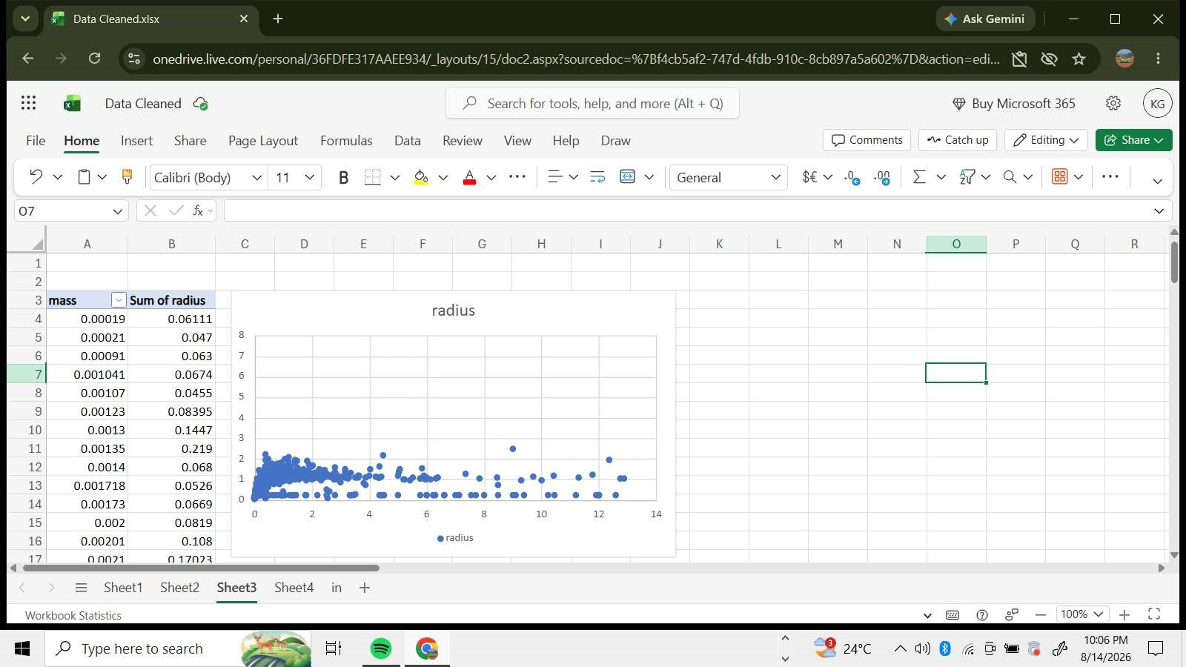
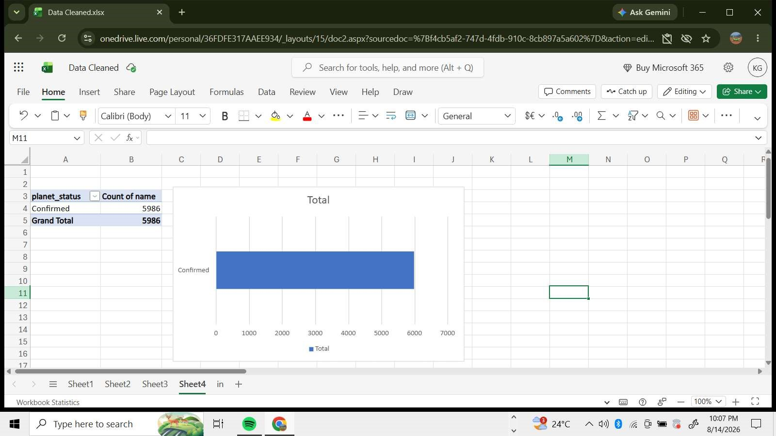
2; onedrive.live.com/personal/36FDFE317AAEE934/ layouts/15/doc2.aspx?sourcedoc=%7Bf4cb5af2-747d-4fdb-910c-8cb897a5a602%7D&action=edi...
Cleaned p Search for tools, help, and more (Alt + Q) Buy
File Home Insert Share Page Layout Formulas Data Review View Help Draw Comments Catch up Editing v Share
9 Calibri (Body) v 11 v General
Al na me

o

1 name planet sta mass mass erro mass erro mass Sinl mass Sinl mass sini radius radius error m In 2 109 Psc b Confirmed 5.743 0.289 1.011 6.383 0.078 0.078 1.152 0.02 3 112 b Confirmed 0.37 0.005 0.004 0.033 0.005 0.219 0.02 4 112 Pscc Confirmed 9.866 1.781 3.19 0.7315 0.0493 0.05 0.219 0.02
- 11 UMi b Confirmed 0.37 1.1 1.1 11.0873 1.1 1.1 0.219 0.02
- 14 And Ab Confirmed 0.37 0.23 0.23 4.684 0.23 0.23 0.219 0.02 7 14 Her b Confirmed 8.9 1.7 1.3 4.95 0.0493 0.05 0.219 0.02
- 14 Her c Confirmed 7.9 1.2 1.6 7.12 0.0493 0.05 0.219 0.02
- 16 cyg Bb Confirmed 0.37 0.08 0.08 1.64 0.08 0.08 0.219 0.02 10 18 Del Ab Confirmed 0.37 0.36 0.36 10.3 0.36 0.36 0.219 0.02
- 23 Lib b Confirmed 0.37 1.59 0.219 0.02
- 23 Lib c Confirmed 0.37 0.03 0.03 0.82 0.03 0.03 0.219 0.02
- 24 Boo b Confirmed 0.37 0.11 0.11 0.91 0.11 0.11 0.219 0.02
- 24 Sex b Confirmed 0.37 0.11 0.11 1.84 0.11 0.11 0.219 0.02
- 24 Sex c Confirmed 0.37 0.2 0.2 1.52 0.2 0.2 0.219 0.02 16 2M 1253+ Confirmed 0.37 0.2 1.8 8.3 0.2 1.8 0.219 0.02
17 )MISIO n nai n 7215
Sheet 1 Sheet2 in
Statistics
p Type here to search
planet with highest mass
12.934
Planet with lowest mass
0.00019
Avergae mass
0.748130528
Avergae radius of tghe planets
0.34852117
100% V +
1007
240C

